DOCUMENT OF THE COLLEGE ATTENDANCE MANAGEMENT SYSTEM

Project Title:

College Attendance Management System

Aim :

The aim of this project is to design and develop a College Attendance Management System using C language to record, store, and display student attendance details in a simple and efficient way.

INTRODUCTION

The College Attendance Management System is a C-based mini project that helps teachers maintain student attendance records digitally.
This system allows the user to add student details, mark attendance, and view attendance reports.
It reduces paperwork, saves time, and improves accuracy compared to manual attendance registers.

Algorithm

1. Start the program

2. Display menu

Add Student

Mark Attendance

View Attendance

Exit

3. Read user choice

4. Perform selected operation

5. Repeat until Exit is chosen

6. Stop the program

Flow Chart

Start
|
Display Menu
|
Read Choice
|
--------------------------------
| Add Student |
| Mark Attendance |
| View Attendance |
| Exit |
--------------------------------
|
Perform Selected Operation
|
Repeat Menu
|
End

---

Module Wise Explanation

Module 1: Add Student

Stores student roll number and name

Module 2: Mark Attendance

Marks student as Present or Absent

Module 3: View Attendance

Displays all student attendance records

Module Wise Code

1. Add Student Module

void addStudent() {
printf("Enter Roll No: ");
scanf("%d", &s[n].roll);
printf("Enter Name: ");
scanf("%s", s[n].name);
s[n].attendance = 0;
n++;
}

---

2. Mark Attendance Module

void markAttendance() {
int roll, i;
printf("Enter Roll No: ");
scanf("%d", &roll);

for(i = 0; i < n; i++) {
if(s[i].roll == roll) {
s[i].attendance = 1;
printf("Attendance Marked Present\n");
return;
}
}
printf("Student Not Found\n");
}

---

3. View Attendance Module

void viewAttendance() {
int i;
printf("\nRoll\tName\tStatus\n");
for(i = 0; i < n; i++) {
printf("%d\t%s\t%s\n",
s[i].roll, s[i].name,
s[i].attendance ? "Present" : "Absent");
}
}

Module Integration Code (Main Program)

#include <stdio.h>

struct student {
int roll;
char name[20];
int attendance;
} s[50];

int n = 0;

void addStudent();
void markAttendance();
void viewAttendance();

int main() {
int choice;
do {
printf("\n1.Add Student\n2.Mark Attendance\n3.View Attendance\n4.Exit\n");
printf("Enter choice: ");
scanf("%d", &choice);

switch(choice) {
case 1: addStudent(); break;
case 2: markAttendance(); break;
case 3: viewAttendance(); break;
case 4: printf("Exiting...\n"); break;
default: printf("Invalid Choice\n");
}
} while(choice != 4);

return 0;
}

Sample Output::

1.Add Student
2.Mark Attendance
3.View Attendance
4.Exit
Enter choice: 1
Enter Roll No: 101
Enter Name: siva

Enter choice: 2
Enter Roll No: 101
Attendance Marked Present

Enter choice: 3
Roll Name Status
101 siva Present

Conclusion:

The College Attendance Management System developed using C language provides an easy way to manage student attendance records.
It reduces manual work, saves time, and avoids errors.
This project improves basic programming skills such as structures, functions, and arrays.
It is suitable for beginners and can be extended with file handling for real-time applications.

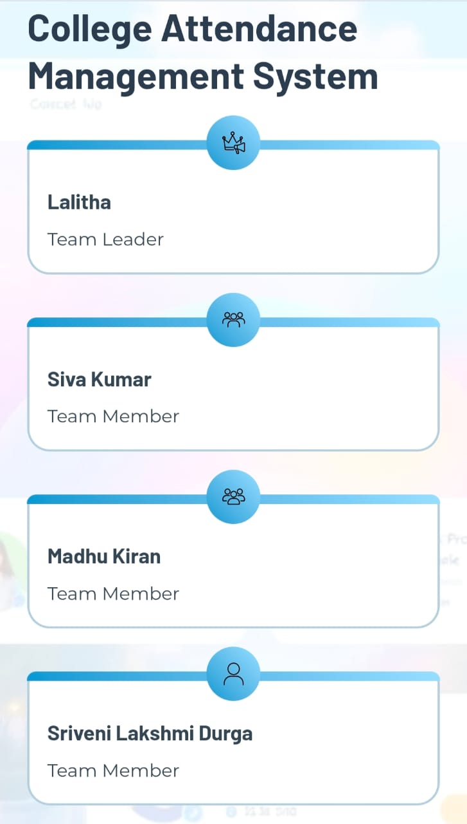

Thank You 👍

THANK YOU
(End of Project)

